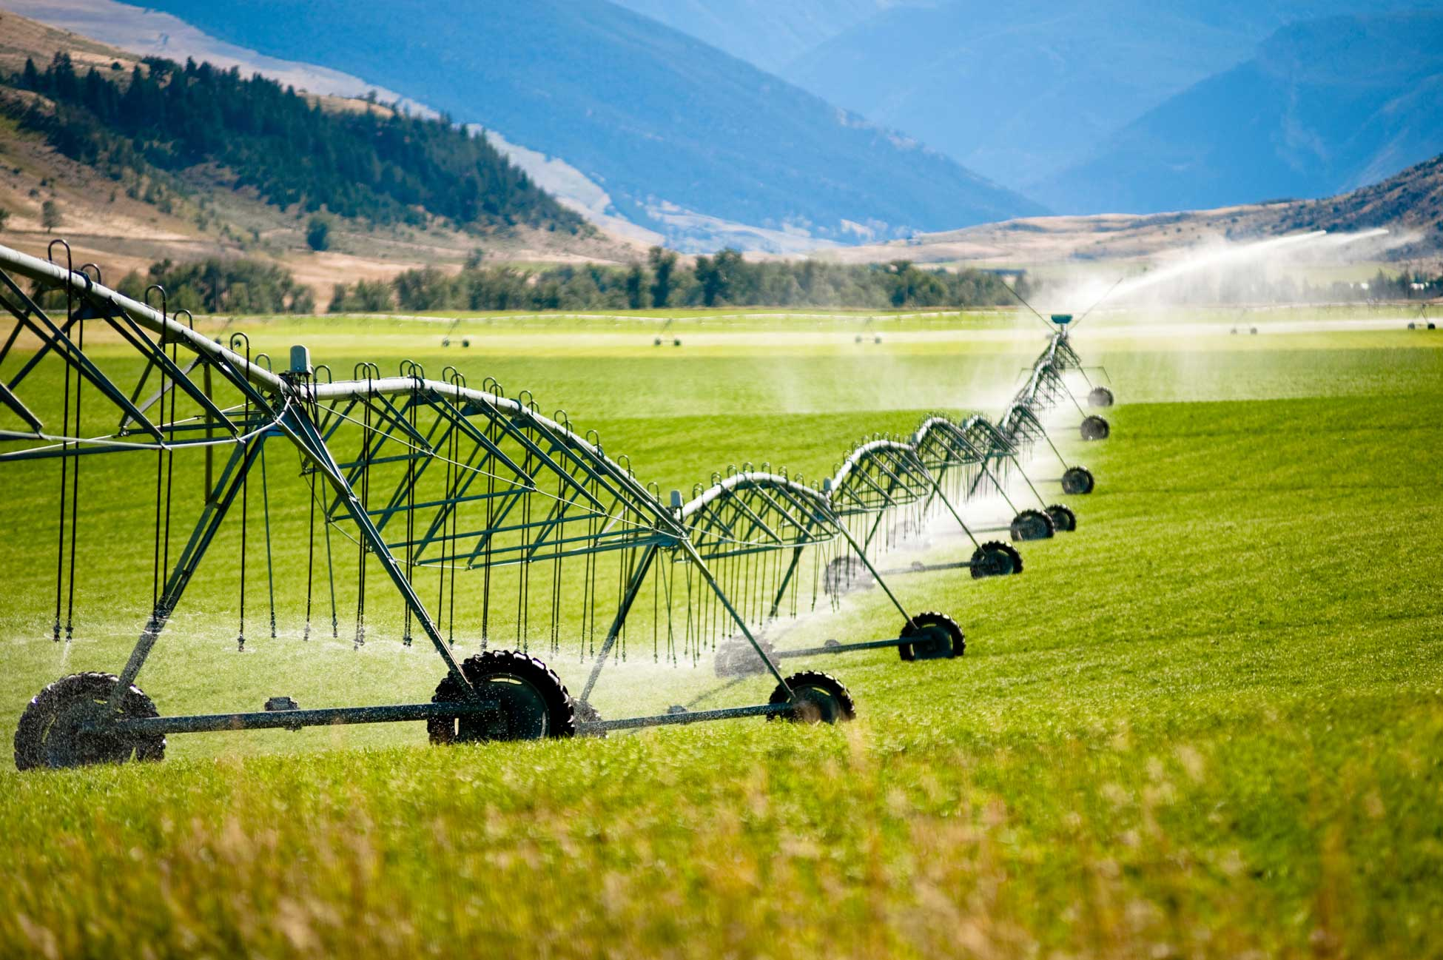

Dual Formulation of Profit Maximization for Crop Irrigation
Using the General Algebraic Modeling System
(GAMS)

Talha Quddoos- A02469393
Dr. David E. Rosenberg
CEE 6410- Civil Engineering Systems Analysis in the Age of Uncertainty
October 02, 2026

Introduction
The excess capacity of the industrial aqueduct for June, July, and August was planned to be used to grow hay and grain on up to 10,000 acres of land. A linear programming approach involving the primal and dual models (in the GAMS environment) was used to find optimal solutions. The report discusses model formulation and the results of both approaches.

Model Formulation
In the given problem, we have two dimensions: the crop are to plant [hay and grain] and the resources available [water (for June, July, and August), and land]. We have to decide the planting of hay and grain in such a way that it consumes under 14000 acft water in june, under 18000 acft water in july and under 6000 acft of water in august while covering the total plantation area of 10,000. The primal model (decision vars 2,constraints 4) is as follows.
Decision Variables | H : | hay to plant (acres)
Decision Variables | G: | grain to plant (acres)
Objective Function (P) | Max 100H+120G | maximizing return ($)
subject to  Constraints | 2H + G $≤14,000$ | june water requirement (acft)
subject to  Constraints | H + 2G $≤18,000$ | july water requirement (acft)
subject to  Constraints | H $≤6,000$ | august water requirement (acft)
subject to  Constraints | H+G$≤10,000$ | land available (acres)
 | H,G$≥$0 | non-negativity

In the dual model formulation constraints of primal model become dual decision variables, and decision variables of primal model become our dual constraints, the objective function shifts from maximization of returns to minimization of resource-related costs. The model is supposed to minimize the cost of resources such that is no less than the per acre return of the crops (hay or grain). The dual model (decision vars 4, constraints 2) of our primal is as follows.
Decision Variables | Y1 | june water cost ($/acft)
Decision Variables | Y2 | july water cost ($/acft)
Decision Variables | Y3 | august water cost ($/acft)
Decision Variables | Y4 | land cost ($/acres)
Objective Function (R) | Min 14,000Y1+18,000Y2+6,000Y3+10,000Y4 | minimizing resource ($)
subject to  Constraints | 2Y1 + Y2 +Y3+Y4 $≥100$ | hay return($/acre)
subject to  Constraints | Y1+2Y2+Y4 $≥120$ | grain return($/acre)
 | Y1,Y2,Y3,Y4 $≥$ 0 | non-negativity

Conclusion and Recommendations
The primal resulted in a maximum return values of $1,160,000 (with a combination of 8000 acres of grain and 2000 acres of hay) and marginal values 0,20,0 and 80 for water utilization in June, July, August, and land, indicating that water availability in July and the land available are the binding constraints, having shadow values of $20 and $80, which is equal to the minimum resource value in the dual. The dual of an LP problem is an effective approach in reducing the processing constraint on the machine by reducing the nodes in the problem (i.e by reducing the number of constraints) while achieving the same results (for example, in our example, both the primal and the dual results indicate the same optimal value of $1,160,000. Moreover, both the primal and the dual achieve the same results, indicating the same usefulness.
- The dual formulation of the dual formulation results in the primal formulation of the problem.
- In dual formulation, the shadow values correspond to the optimum values of our primal decision variables, indicating the change in the values of the objective function per unit increase in the value.

Use of Artificial Intelligence (AI)
Claude AI was used to refresh the concepts https://claude.ai/share/3d9bc6db-7260-4aa3-ba89-d5213108961f.

Github
https://github.com/talha-q/CEE6410-Engineering-Systems

References
GAMS Development Corporation. General Algebraic Modeling System (GAMS) Release: 54.4.0 , Fairfax, VA, USA, 2026 .

Week Feedback
I am really enjoying the course, though at times I struggle with the concepts. It would help a lot if the reading material included worked examples with units of measurement, along with an explanation of the results and the reasoning behind them. I usually go through the readings before starting an assignment, and having that kind of reference would make it easier to review and apply the concepts on my own.

